因應本校武漢肺炎防疫工作
【In response to Wuhan pneumonia prevention work】
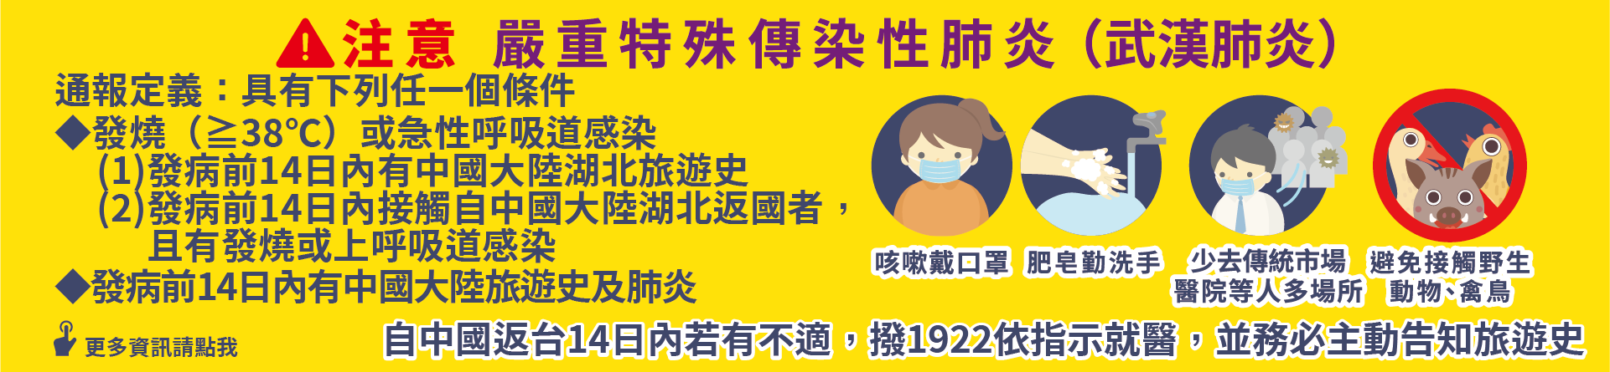
請肥皂洗手或酒精噴手
戴上口罩
測量體溫並記錄，每日至少量測體溫1-2次
再進入
〜Prevent infection〜
★Please sanitize (sprayer) your hands
with alcohol or wash your hands with
soap.
★Please wear a mask.
Measure body temperature at least 1-2 times a day and record.

Thanks for your cooperation

